User Manual for the One of a Kind App

1.Downloading and Updating the App 1

2. App and Tasks Overview 2

2.1. Opening the app 2

2.2. Title screen and Intro screen 2

2.3 Main menu 4

2.4 Tasks Structure 4

2.4.1 General task structure 4

2.4.2 Task structure with parental assistance 5

# 1.Downloading and Updating the App

The app can be downloaded via a insert link here or Google Play store (search: “One of a Kind App”) store.

If you are downloading the app via a link:

* Click the link
* Click Package Installer if prompted
* Wait until loaded
* Wait until staged
* If updating - when asked to install an update, click install
* If installing for first time - accept all messages
* If the package fails to download, report the problem by contacting a member of our team: [julia.koziel@kcl.ac.uk](mailto:julia.koziel@kcl.ac.uk)

The app can also be searched for in the Google Play Store. It will be published there under the name of “One of a Kind App”.

* Find the app
* Download onto your tablet or Smartphone

# 2. App and Tasks Overview

## 2.1. Opening the app

The app is called Time Trekkers and can be opened by clicking on this icon:

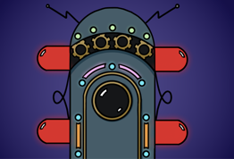

## 2.2. Title screen and Intro screen

Upon opening the app, the title screen of the app “Time Trekkers” appears.

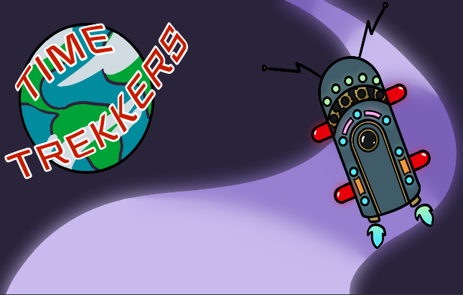

After the title screen, the main character Theo introduces the games and presents the chil with the intro screen.

Intro screen:

1. Enter your participant ID. You can generate your ID on our website here:  
 Please do not enter your/ your child’s name

2. The games were created for children with typical development or neurodevelopmental conditions. Different children may prefer to have instructions either a) [give example] or b) [give example]. Therefore, you/ your child can personalise these instructions by toggling various functions, such as XYZ on and off.

This toggle button allows the child to select playing the game on his/ her own or with a parent. The default option is playing the game without parental assistance.

Toggle options:

A. This toggle button allows the child to select an option of having subtitles (text boxes). The default option is having the subtitles on.

B. . This toggle button allows the child to toggle off sound. The default option is having the sound on.

C. After choosing their preferences, children can proceed to the main menu by pressing the “Start the game” button.

## 2.3 Main menu

The main menu screen currently contains four tasks. After clicking a task, child is informed about the time in the past (era) that they are being transported to.

## 2.4 Tasks Structure

All tasks follow a similar structure when your child is playing the games by herself/ himself. However, if you are playing the games with your child, you n can repeat some parts of the game if your child didn’t fully understand them the first time round

We chose to use buttons with consistent symbols throughout the app to create a sense of familiarity for children with autism or others who may struggle with unfamiliar elements.

### 2.4.1 General task structure

**1. Animation**

Each game starts with an animated cartoon. The cartoon introduces children to the rules of the game in an entertaining way.

**2.Demonstration**

The main character (Theo) demonstrates the rules of the game.

**3. Pre-test**  
It is a short but robust test that assesses whether children have the basic levels of comprehension to play the game according to the rules.   
  
**4. Practice**

Children get to practice the game before proceeding to the trials.

### 2.4.2 Task structure with parental assistance

**1. Animation  
  
2. Demonstration**

**3. (Optional) Parent demonstration* of the game  
You (the parent)** can also demonstrate the rules of the game if your child did not attend to the previous demo or did not understand the rules.

**4. Pre-test  
  
5. (Optional) Parent demonstration of pre-test**  
If a child fails to pass a pre-test and is currently being assisted by their parent, parents can demonstrate the correct response.  
  
**6. Child Practice**

*The elements which indicate the need for parental input are signified by this button:

